|  |  |  |  |  |  |  |  |  |  |  |  |
| --- | --- | --- | --- | --- | --- | --- | --- | --- | --- | --- | --- |
| **Student Details (Student should fill the content)** | | | | | | | | | | | |
| Name | | Bashitha Mananjitha Wearagodaarachchi | | | | | | | | | |
| Student ID | | ST20307114 | | | | | | | | | |
| **Scheduled unit details** | | | | | | | | | | | |
| Unit code | | CIS6003 | | | | | | | | | |
| Unit title | | Advanced Programming | | | | | | | | | |
| Unit enrolment details | | Year | | | | 3 | | | | | |
| Study period | | | |  | | | | | |
| Lecturer | |  | | | | | | | | | |
| Mode of delivery | | Full Time | | | | | | | | | |
| **Assignment Details** | | | | | | | | | | | |
| Nature of the Assessment | | **Course work 100%** | | | | | | | | | |
| Topic of the Case Study | | **Lab Appointment System** | | | | | | | | | |
| Learning Outcomes covered | | **1,2,3** | | | | | | | | | |
| Word count | |  | | | | | | | | | |
| Due date / Time | | Jan 2024 | | | | | | | | | |
| Extension granted? | | Yes | | | No | Extension Date | | | |  | |
| Is this a resubmission? | | Yes | | | No | Resubmission Date | | | |  | |
| **Declaration** | | | | | | | | | | | |
| I certify that the attached material is my original work. No other person’s work or ideas have been used without acknowledgement. Except where I have clearly stated that I have used some of this material elsewhere, I have not presented it for examination/assessment in any other course or unit at this or any other institution | | | | | | | | | | | |
| Name/Signature | |  | | | | | | Date | |  | |
| **Submission** | | | | | | | | | | | |
| Return to: | |  | | | | | | | | | |
| **Result** | | | | | | | | | | | |
| Marks by 1st Assessor |  | | Signature of the 1st Assessor | | | | | |  | | **Agreed Mark** |
| Marks by2nd Assessor |  | | Signature of the 2nd Assessor | | | | | |  | |
| **Comments on the Agreed Mark.** | | | | | | | | | | | |
| **For Office use only (hard copy assignments)** | | | | | | | | | | | |
| Receipt date |  | | | Received by | | |  | | | | |

|  |  |  |  |  |
| --- | --- | --- | --- | --- |
| **STUDENT NAME:** | | **STUDENT NUMBER:** | | |
| **Module Number & Title**: | | **Semester:** | | |
| **Assignment Type & Title:** | |  | | |
| **For student use: Critical feedback on the individual progression towards achieving the assignment outcomes** | | | | |
|  | | | | |
| **For the Assessors’ feedback**  **Indicate the Task number strengths and Weaknesses and the marks for each task** | | | | |
| **Task No/Quest ion No** | **Strengths** | | | |
| **Task No /**  **Question**  **No** | **Weaknesses** | | | |
| **Areas for future improvement** | | | | |
|  | | | | |
| **Marks** | | | | |
| **Task**  **/Question No** | **Allocated Marks** | | **Awarded Marks** | **Remarks** |
|  |  | |  |  |
|  |  | |  |  |
|  |  | |  |  |
|  |  | |  |  |
|  |  | |  |  |
| **Total Marks** |  | |  |  |
| **Name and the Signature of the Assessor** |  | | | |
| **Date** |  | | | |

# **Acknowledgement**

First, I wish to thank our lecturer of Mr. Thamara Vidyarathne for the invaluable guidance and knowledge throughout this project development. Next my thank will be for all academic nonacademic staff at ICBT Campus and Cardiff metropolitan University for provide us greatest facilities to learn. Finally, my family members must have my thank for their greatest support to complete project work successfully.

# **Exclusive Summary**

This software Solution is for ABC Laboratories Pvt Ltd Company. Who provides medical services based in Sri Lanka. This Web Lab Appointment system is to replace their current call and paper-based appointment system. In the first section we have provided the SRS documentation and Next Sections have respectively contained Design pattern implementations, Test Plan documentation, User and Technical Documentation.

Table of Contents

Acknowledgement 4

Exclusive Summary 5

Tasks A 7

Software Requirements Specification 7

Introduction 7

Document Purpose 8

System Requirement 9

Functional Requirements 9

Nonfunctional Requirements 10

User Interfaces 11

Tasks B 15

Use Case Diagram 15

User Registration 16

Book Appointment 19

Admin Login 22

Add Report 25

Tasks C 28

Singleton Pattern 28

Factory method pattern 28

Abstract Factory design pattern 28

Tasks D 29

Tasks E 30

Introduction 32

Test Methodology 33

Tasks F 36

User and Technical Documentation 36

Introduction 36

Overall Description 37

Technology Overview 39

Specific Requirements 43

External Interface Requirements 43

User Interfaces 43

Abbreviations 57

References 58

Turnitin Report 59

# 

# **Tasks A**

# **Software Requirements Specification**

# **Introduction**

ABC Laboratories is a leading medical services provider with 15 years of experience in Sri Lanka. They provide wide range of services in medical tests. Currently, all the appointment details and test records are managed manually. The ABC Private Limited company is planning to implement a web-based Lab Appointment System to improve their service and productivity. We introduce the project ABC Laboratories WEB as a web-based software solution for that requirement.

## **Document Purpose**

This document is to provide a comprehensive understanding of the product for our client and stakeholders. This document also will help for the future upgrades of the system. This document provides comprehensive description about the application processes and used technologies. We recommend read this document to get more out from this web application.

# **System Requirement**

## **Functional Requirements**

* User Home

User should be able to view all data about the business in a single page.

* User Registration

User should be able to register and receive unique ID to uniquely identify them in the system.

* Make Appointment

User should be able to make appointments for test by selecting convenient branch and date.

* Admin Login

Admin should be able to login to the system by previously given username and password.

* Admin Dashboard

Admin should be able to view all data manage in the system. They should be able to view update and remove.

* Update Reports

Admin should be able to update released test results in the system when tests done completely.

* View Reports

Patients should be able to view their reports.

Patients should be able to download their reports.

* Receive Email notifications

Patients should be able receive confirmation email when successfully registered to the system

Patients should be able receive appointment confirmation email with appointment data when appointment booked successfully.

Patients should be able receive test notification email when result results released.

## **Nonfunctional Requirements**

* Performance
* The system should handle multiple the users request simultaneously
* The response time should be lower as possible
* Security
* Admin dashboard must be developed to avoid unauthorized access to secure patients’ private data
* Every user input should validate to avoid mistakes and submitting unusable data
* Scalability
* System should be scalable to manage the growing number of use patients, doctors, technicians, test type and new branches.
* Usability
* Interfaces should be simple and clean to minimize the learning curve of the web application.

## **User Interfaces**

The following pages are the planned to developed user interfaces. They designed to get an idea on development and provide customer a good idea about the final product. The application should be similar to these wireframes but not be exact same. The final product can be different from these.

* Home page

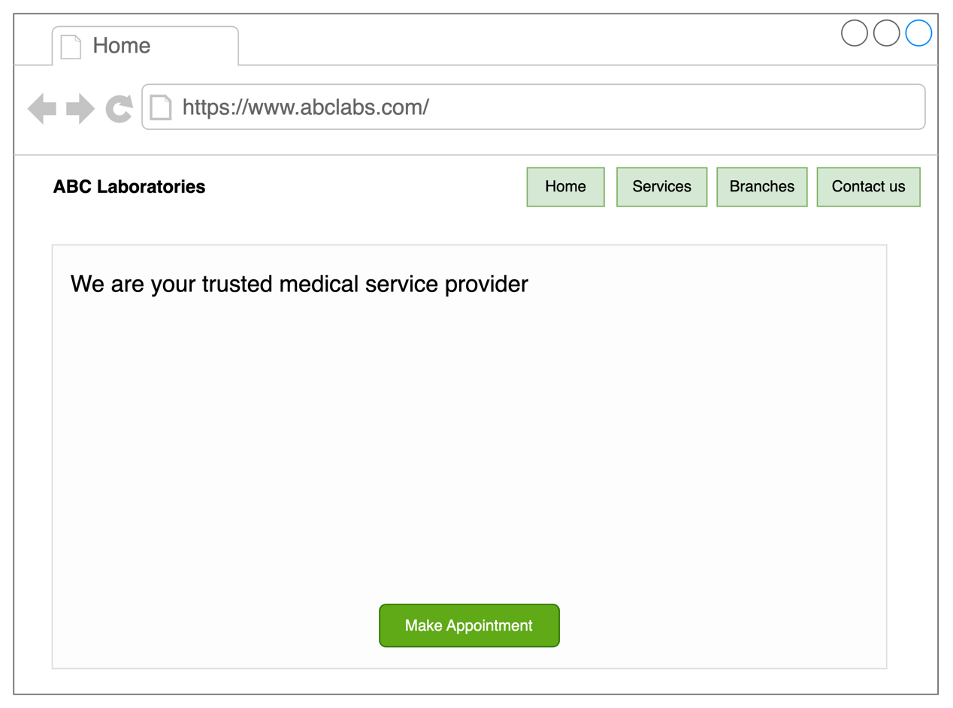

* Appointment Modal

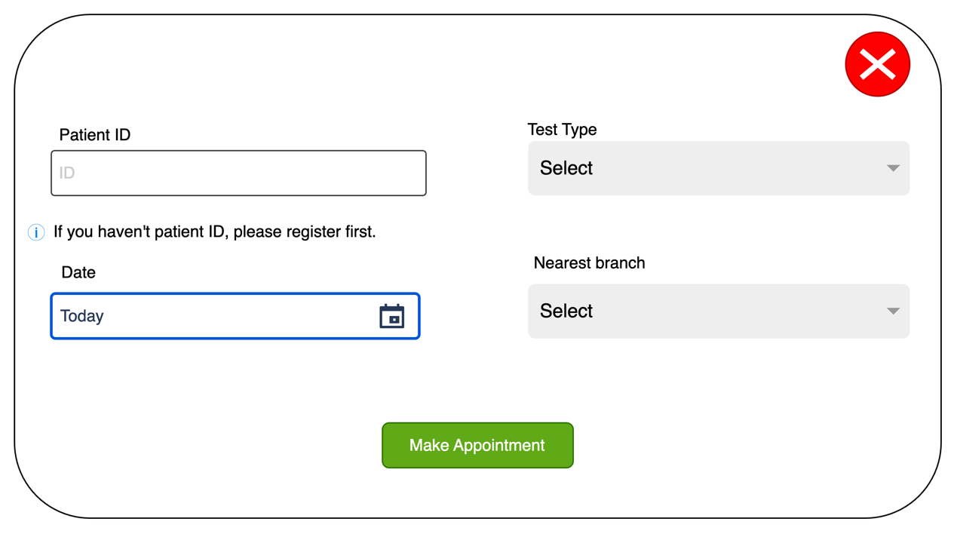

* Report Page

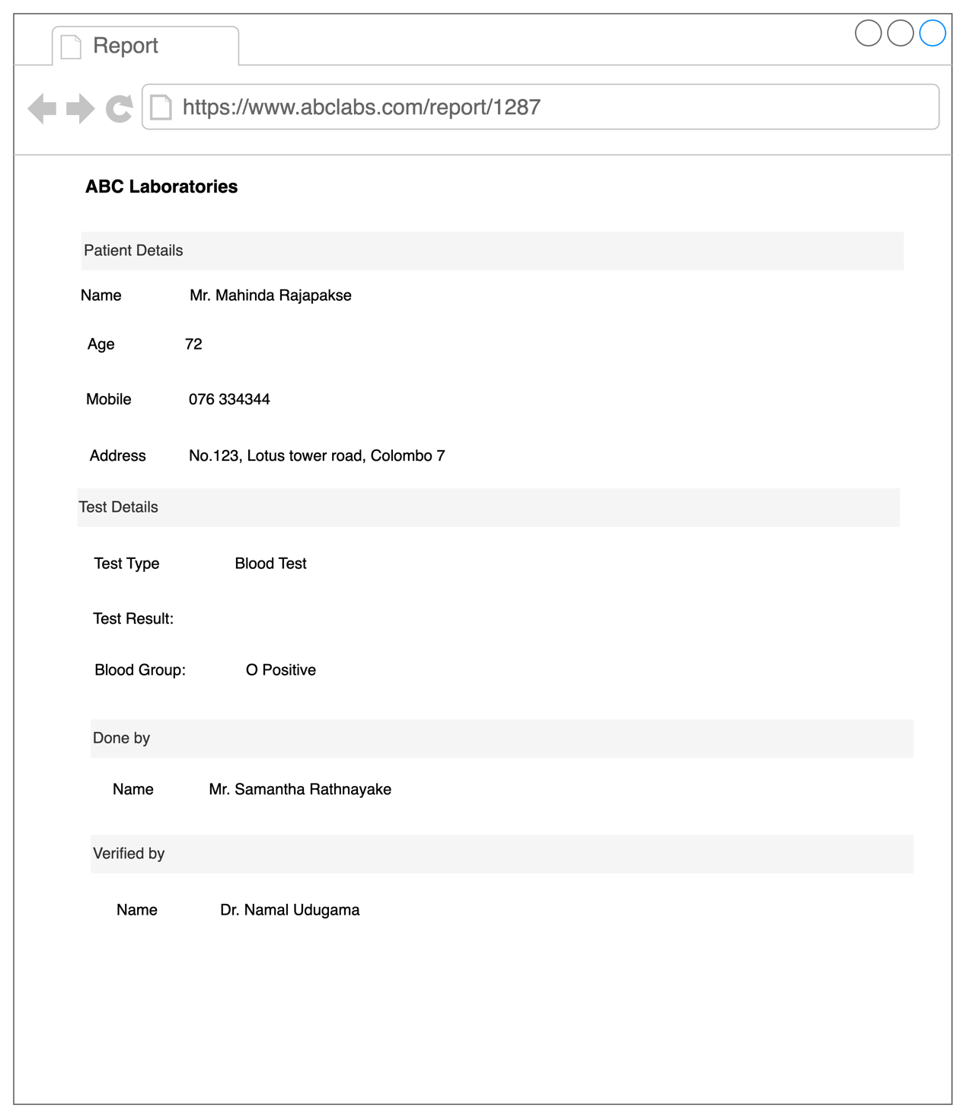

* Admin Dashboard Page

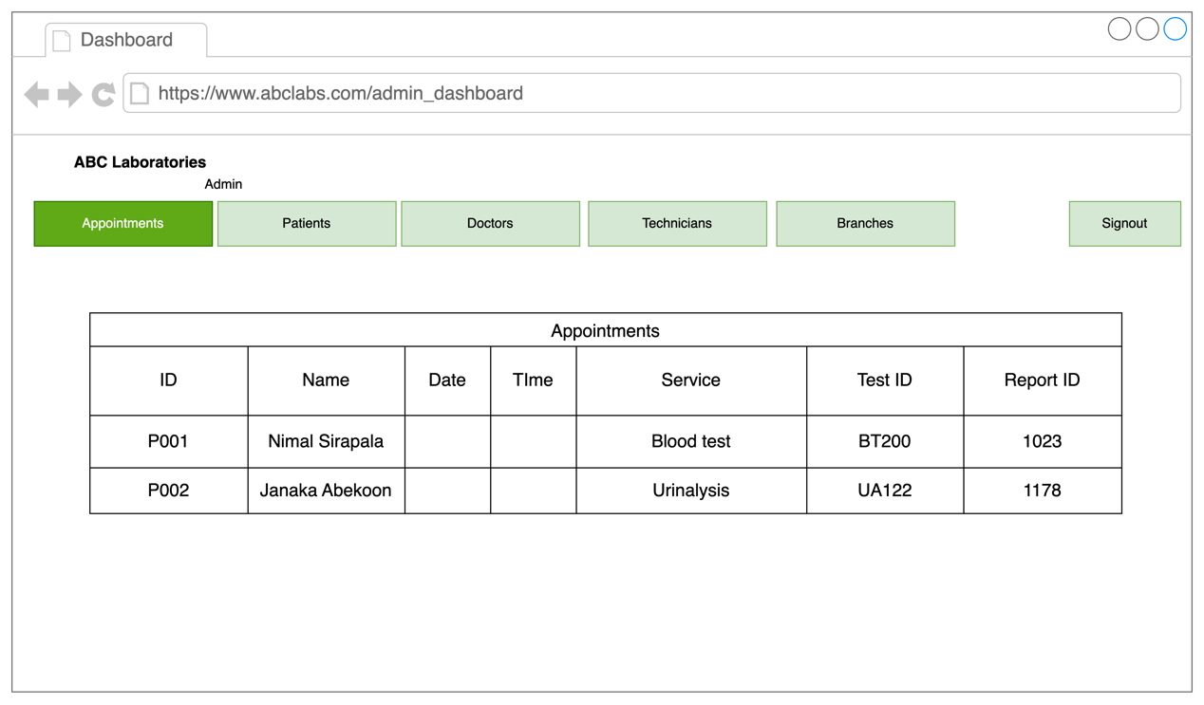

# **Tasks B**

## **Use Case Diagram**

* Patient (Customers) – patients are the main targeted user base. Therefore, we have developed the web application very simple UI and functionalities. To make the system more user friendly we have not provided a patient login functionality. They can use their patient ID to make their appointments and view the reports.
* Super Admin – Super admin has the highest privileges in the system. The main functions of the super admin are managing admins, branches, Technicians and Doctor. They can add, update, and remove admins in the system. (This user type will not develop in first release due to limited time frame, and we focus on customer(patient) and branch admins functionalities.)
* Admin – Admin is the second highest privileged user in the system. Every branch should have one or more admin(s) according to the demand of work load. Mainly they have responsibilities like manage appointment, reschedule appointments, upload the reports etc.

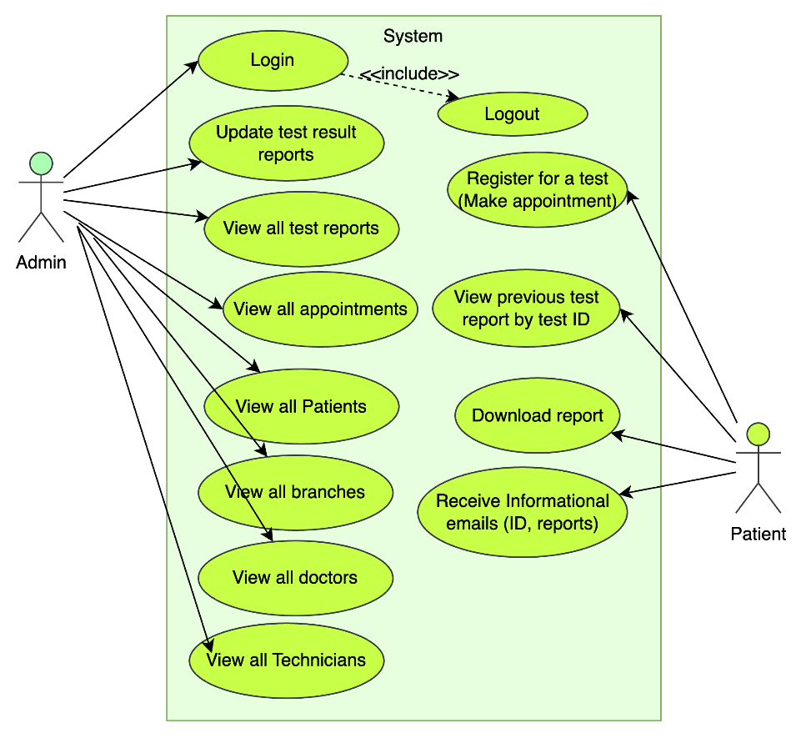

## **User Registration**

* Use Case Diagram

|  |  |
| --- | --- |
| Use Case ID | U001 |
| Use Case Name | Register |
| Short description | Register is use to collect required data from the user and store them for future use. |
| Pre- condition | Patient should not register in the system |
| Post – condition | Patient should be able to register in the system |
| System state in an event of an error | Displays an error message as an alert pop up |
| Actors | Patient |
| Triggers | When user press the Register button |
| Standard process | 1. Click “Haven’t account yet. Sign up” link 2. Fill all required fields 3. Click sign up button 4. Receive confirmation email |
| Alternative process | 1. User Enter invalid data 2. Stop register process and alert error message |

* Class Diagram

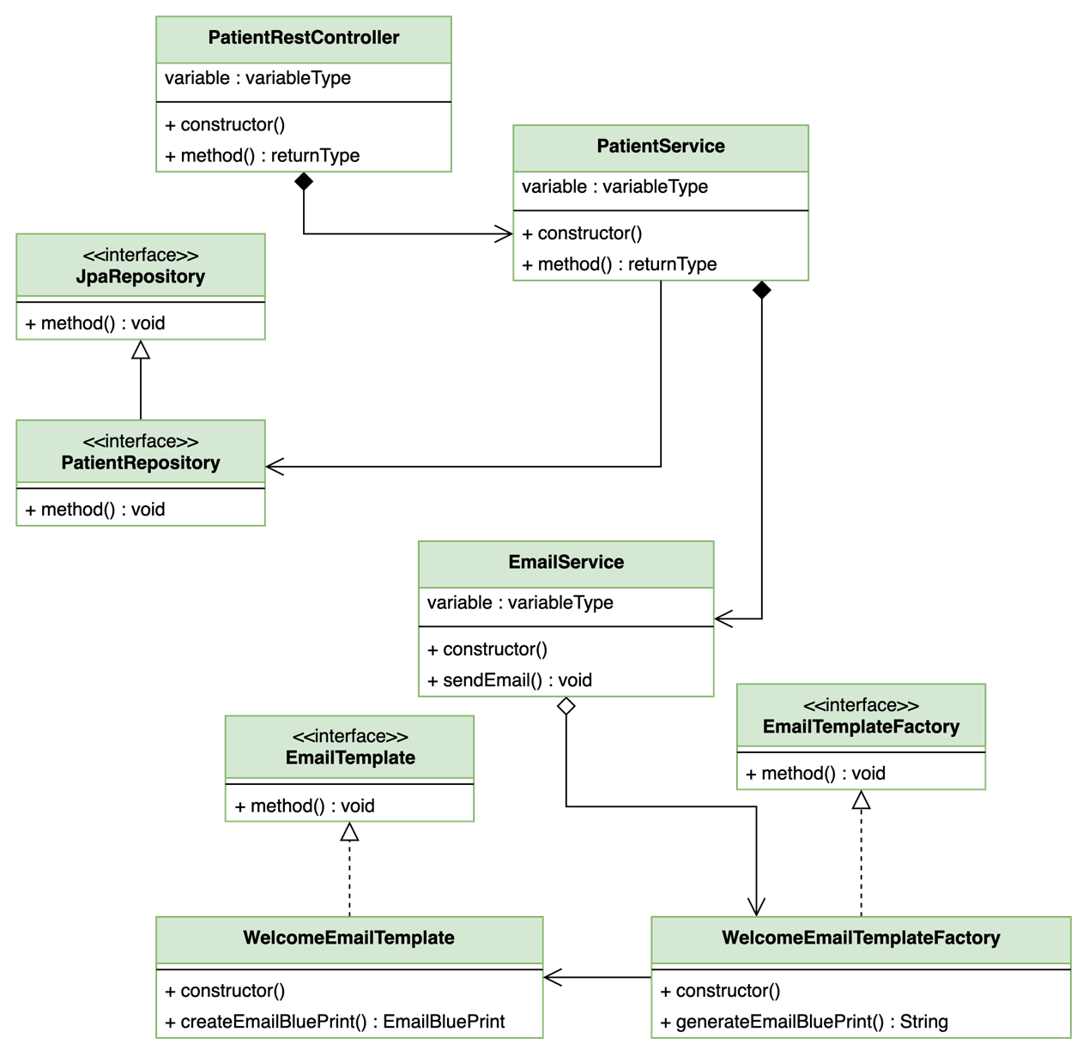

* Sequence Diagram

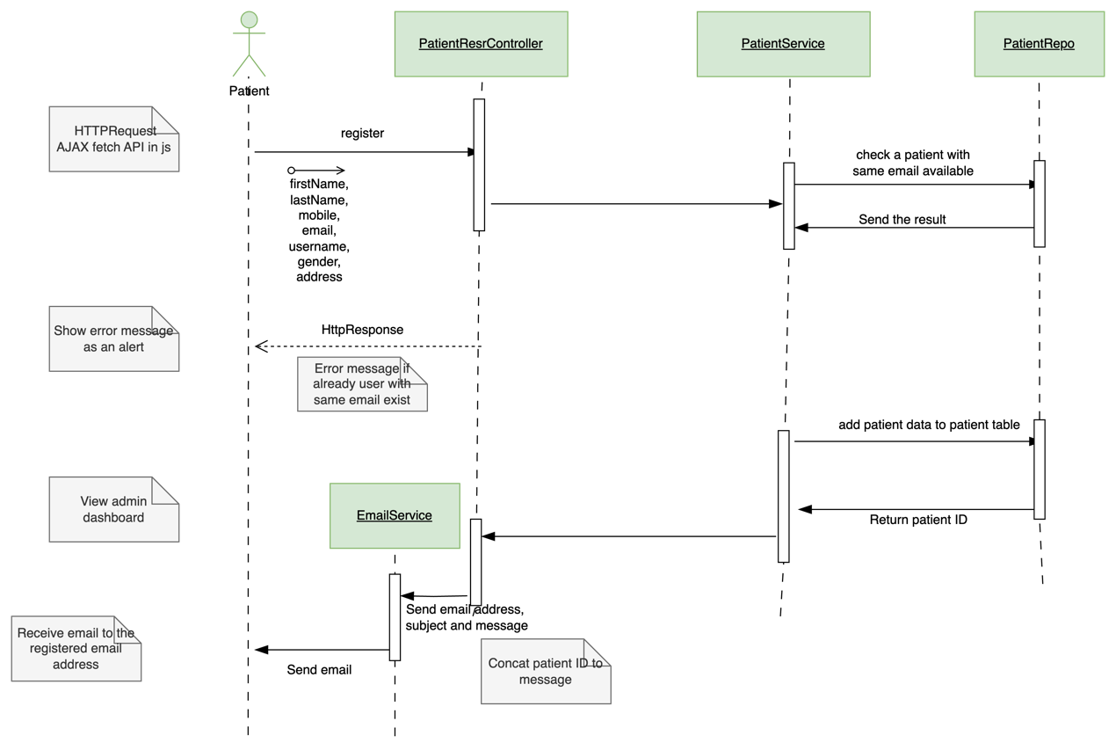

## **Book Appointment**

* Use Case Diagram

|  |  |
| --- | --- |
| Use Case ID | U002 |
| Use Case Name | Make Appointment |
| Short description | Make appointment is use to reserve a test appointment using web application. |
| Pre- condition |  |
| Post – condition | Patient should be able to reserve the appointment and receive confirmation email |
| System state in an event of an error | Displays an error message as a pop up |
| Actors | Patient |
| Triggers | When user press Make Appointment button in Appointment page |
| Standard process | 1. Click Make appointment button in home page 2. Enter and select all required data 3. Click book appointment button |
| Alternative process | 1. Older date selected for the appointment date 2. Stop process and show error message alert |

* Class diagram

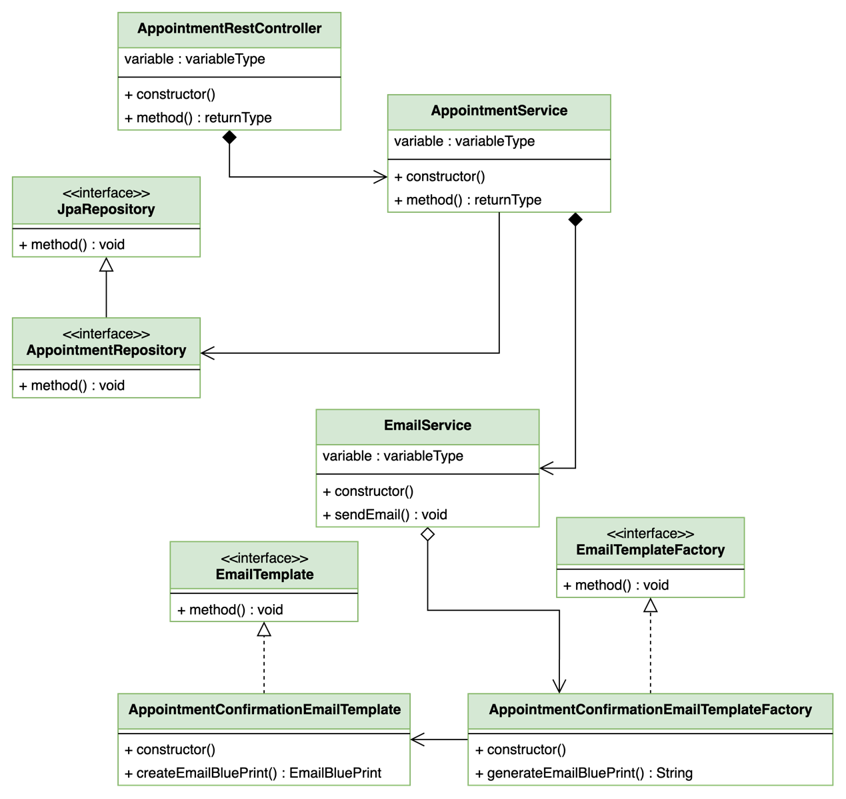

* Sequence diagram

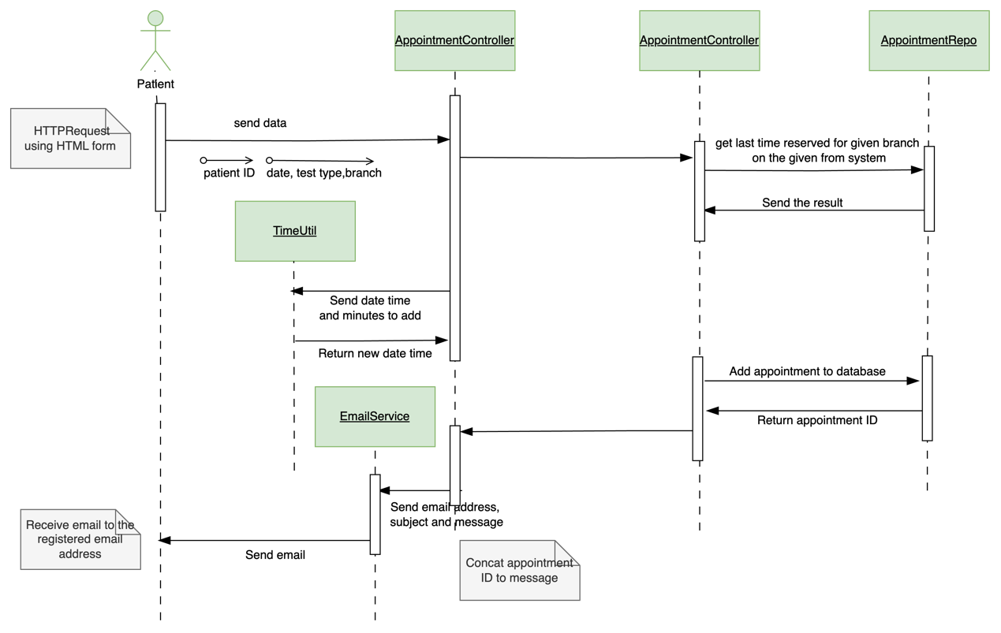

## **Admin Login**

* Use Case Diagram

|  |  |
| --- | --- |
| Use Case ID | U003 |
| Use Case Name | Admin login |
| Short description | Admin login is the page where admin can log into the system |
| Pre- condition | Admin must be previously added one into the system |
| Post – condition | Admin should be able to login and view admin dashboard |
| System state in an event of an error | Displays an error message as a pop up |
| Actors | Admin |
| Triggers | When user press login button |
| Standard process | 1. Enter /admin/dashboard or /admin/login on address bar 2. Enter username and password 3. Click login button |
| Alternative process | 1. Incorrect username and password 2. Stop process and alert error |

* Class Diagram

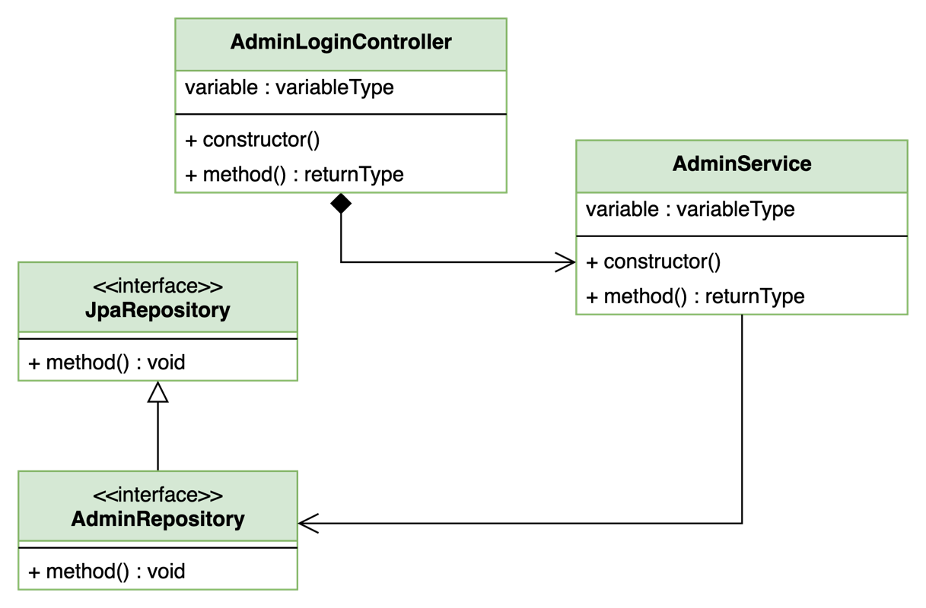

* Sequence Diagram

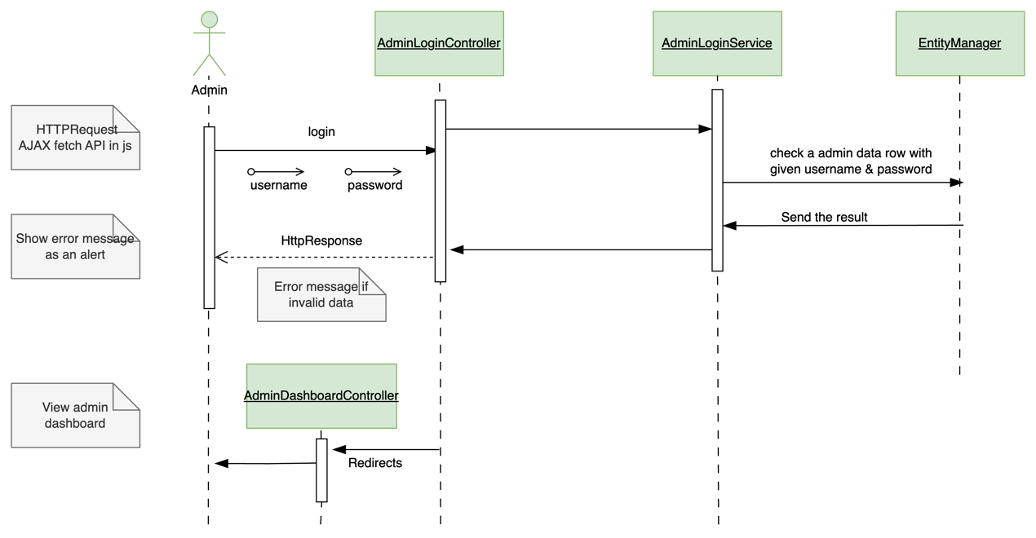

## **Add Report**

* Use Case Diagram

|  |  |
| --- | --- |
| Use Case ID | U004 |
| Use Case Name | Update Report |
| Short description | Update report is use to update the report data when issued from the lab. |
| Pre- condition | Admin must log into the system |
| Post – condition | Admin should be able to update report |
| System state in an event of an error | Displays an error message as a pop up |
| Actors | Admin |
| Triggers | When user press Save button in Update Report page |
| Standard process | 1. Click Update button in appointment relevant dashboard table raw 2. Enter and select all required data 3. Click Save button |
| Alternative process |  |

* Class Diagram

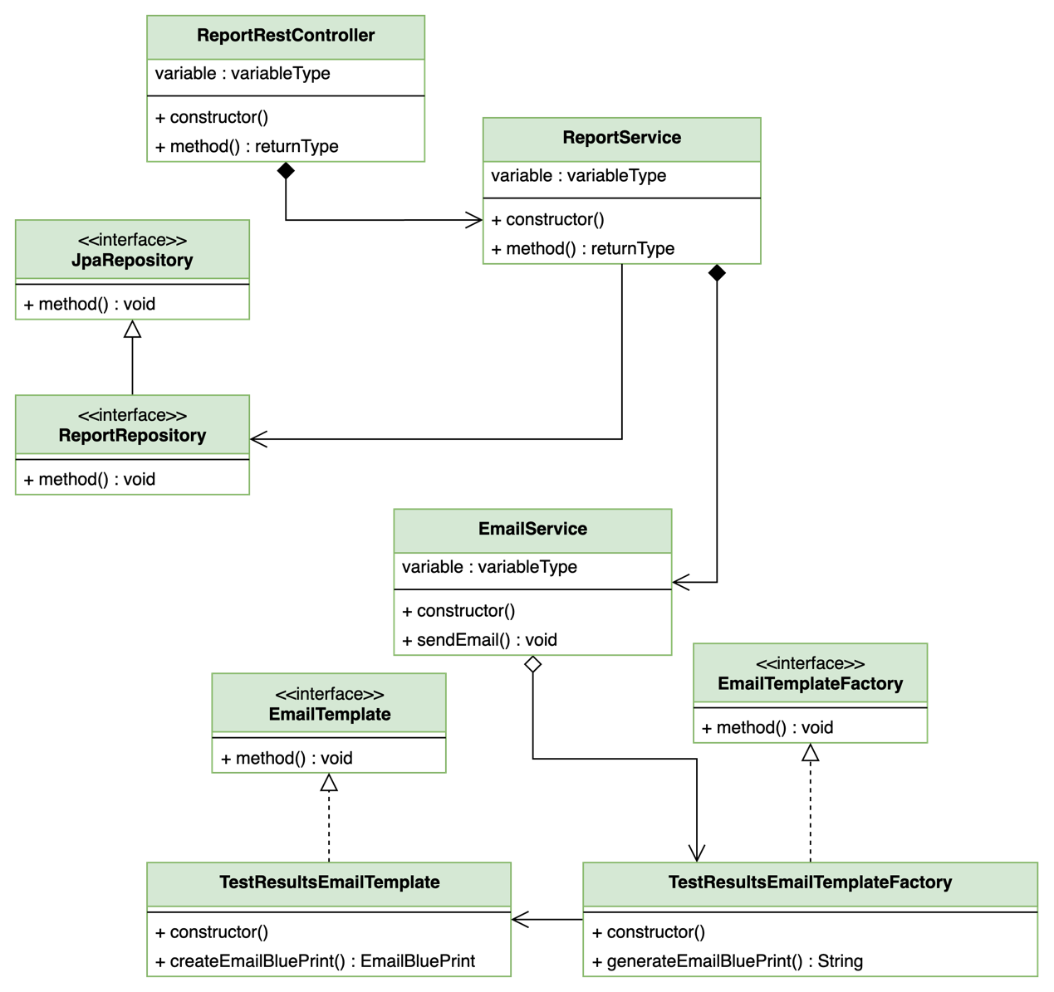

* Sequence Diagram

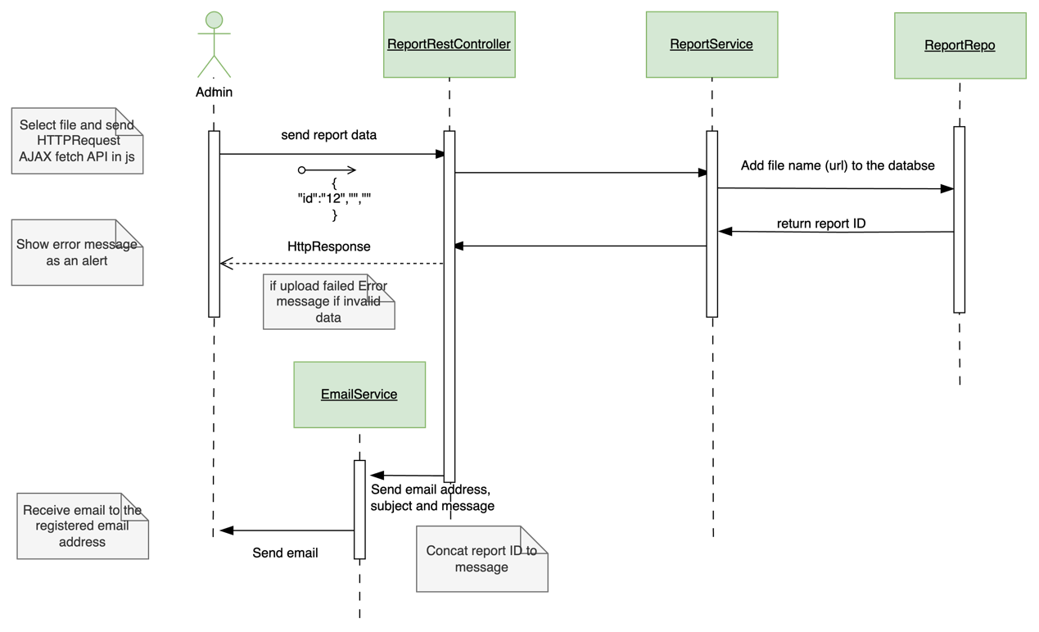

# **Tasks C**

## **Singleton Pattern**

Singleton is a design pattern which comes under creational design patterns which allows programmer to ensure that the class only has one instance and provide global access to that instance (Shvets, 2019).

This pattern can help us reduce resource usage and performance improvement. Because if we create new object for every use, it will use system memory. And also, it removes the new object creation time too. It cannot feel us directly because it gets only few milliseconds to create a object form class. But some scenarios it could lead unexpected behavior in amulet treading environment. Singleton pattern is a very easy design pattern to learn and develop.

## **Factory method pattern**

The Factory Method design pattern is categorised with other design patterns since it offers an interface for creating objects within a super class. permits modifications to the object type made by subclasses using the factory method (Shvets, 2019). In terms of development and code maintenance, this pattern is quite helpful. For instance, suppose ABC Laboratories solely offers blood testing at this time. Following the creation of the web application, the company decided to incorporate urinalysis test results into the system due to significant demand. It is necessary to update every codebase that the class depends on in order to update the system and add Urinalysis reports. To make the system functional, however, it is simple to update the Urinalysis class by using an interface as a super class for all reports.

## **Abstract Factory design pattern**

which is categorised under Creational Design Patterns. In this pattern programmers can generate a group of connected objects without specifying their respective concrete classes by using the Abstract Factory design pattern, (Shvets, 2019). We can guarantee that the items we receive from the factory are precisely compatible with one another. Additionally, we can prevent concreate products and client code from being coupled together. The adoption of this pattern has the drawback that it may result in complex code since it requires the introduction of numerous classes and interfaces.

# **Tasks D**

When develop the application we tried to maintain industrial grade MVC architecture. The Spring boot framework helps us a lot to achieve that. We have used the factory method pattern to create three different email templates. It helps a lot to maintain a good structure. And also we used the Singleton pattern in some utility classes such as Time Calculator.

Before development start, we planned the application database. Which helps a lot to develop the application successfully? We use Java Persistence API to auto generate the table structure when application deploy. The following ER diagram is a simple ER diagram which represent underlined database Entity (table) structure.

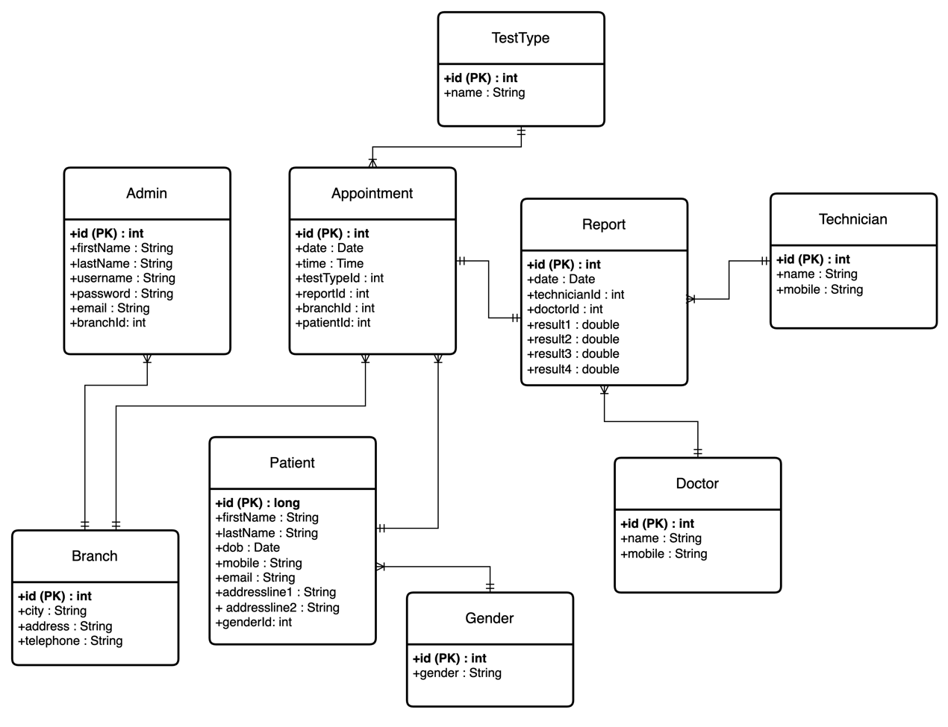

# **Tasks E**

**Test Plan for ABC Laboratories Web Project**

**Version 1.0**

*ChangeLog*

|  |  |  |  |
| --- | --- | --- | --- |
| **Version** | **Change Date** | **By** | **Description** |
| version number | Date of Change | Name of person who made changes | Description of the changes made |
|  |  |  |  |
|  |  |  |  |

Introduction 25

Purpose 25

Scope 25

In Scope 25

Out of Scope 25

Quality Objective 25

Roles and Responsibilities 25

Test Methodology 25

Overview 25

Test Strategy 26

Manual Testing 26

Automated Testing 26

Performance Testing 26

Test Completeness 26

Test Deliverables 26

Testing Tools 26

Test Environment 26

Terms/Acronyms 27

# **Introduction**

* Purpose

The purpose of this document to outline the test plan incluidng test approch, strategies, activities and roles of the testing with their responsibilities.

* Scope

In Scope,

* Home page
* Make appointment page
* Patient Registration Page
* Admin Login
* Admin Dashboard
* Update Report
* Email Sending

Out of Scope,

* Report generation
* Reports Reliability
* Responsiveness on wearable smart devices (e.g.: - Smart watches)

* Quality Objective
* Ensure the Application Under Test conforms to functional and non-functional requirements
* Ensure the Application Under Test meets the quality specifications defined by the client
* Bugs/issues are identified and fixed before go live
* Roles and Responsibilities

The following roles will be working on the application testing process.

* QA Analyst
* Test Manager
* Configuration Manager
* Developers
* Installation Team

# **Test Methodology**

* Overview

We use the the waterfall methdology in testing process because the web application developed using the waterfall methology and consider the size of the project.

* Test Strategy
* Manual Testing

Conduct functional testing for all features. Perform usability testing on different browsers and devices. Manually validate data integrity in the database.

* Automated Testing

Implement automated tests for critical functionalities using tools such as Selenium. And also to test Java classes using JUnit testing.

* Performance Testing

By conducting a performance testing we will ensure that the application responsiveness and endurance on different workloads and environments.

* Test Completeness

The testing process will be considerd as complete when,

* 100% test coverage
* All Manual & Automated Test cases executed
* All open bugs are fixed or will be fixed in next release
* Test Deliverables
* Test Design
* Test Cases
* Bug Reports
* Testing Tools

The following tool will be used to test the web application.

* CSS Debugger – Web Frontend debugging tool (Browser Extension)
* Postman – API testing tool
* Junit – Test Java classes
* Test Environment

1. Windows 10 and above
2. Microsoft Edge
3. Google Chrome Version 122.0.6261.112
4. Mozilla Firefox 119.0.1

**Junit Tests**

We have use Test Driven Development (TDD) to speed up the development by ensure the working results. First, we have developed few simple classes in test package. Such as Time Calculator etc. After achieving the working codes, we have started the project initialization and developed the application using continues testing. After the development we have installed the Selenium web driver on Google Chrome browser and tested the application using test automation. Following code is an example code which we use to test a class functions using Junit.

package com.medicaredevelopers.web.abclabs.util;

import static org.junit.jupiter.api.Assertions.*;

import java.sql.Time;

import org.junit.jupiter.api.Test;

class TimeCalculatorTest {

*@Test*

void test() {

TimeCalculator timeCalculator=TimeCalculator.*getInstance*();

Time time=timeCalculator.addMinutesToTime(Time.*valueOf*("09:00:00"),10);

Time timeMustBe=Time.*valueOf*("09:10:00");

*assertEquals*(timeMustBe, time);

}

}

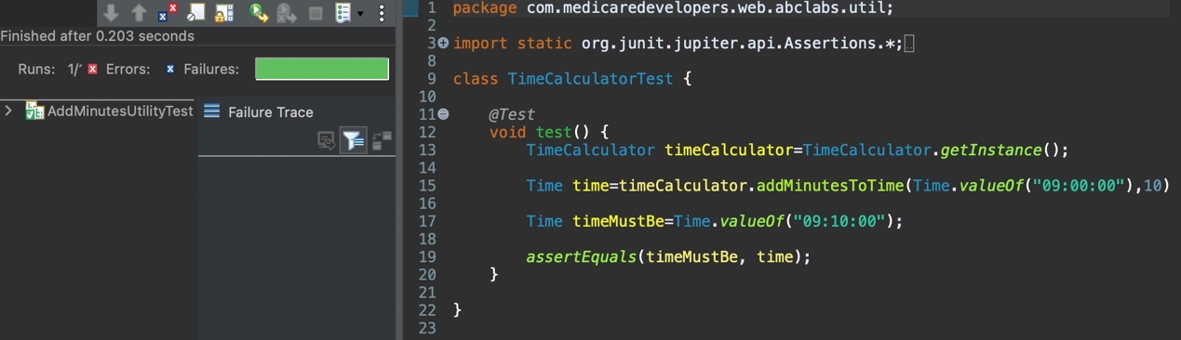

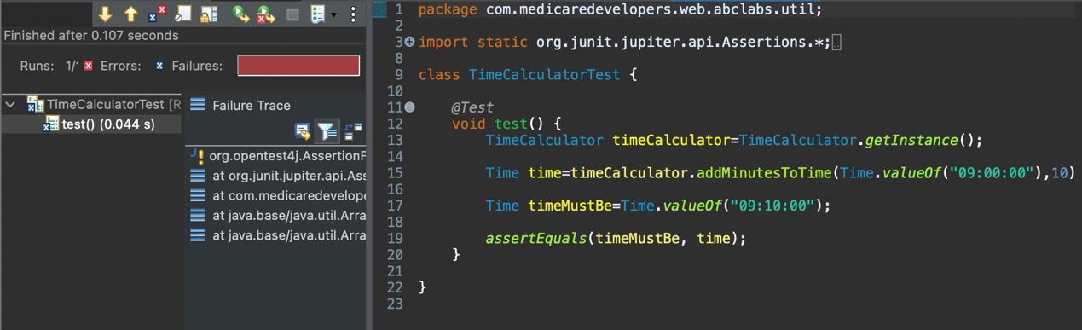

# **Tasks F**

# **User and Technical Documentation**

# **Introduction**

ABC Laboratories is a leading medical services provider with 15 years of experience in Sri Lanka. They provide wide range of services in medical tests. Previously, all the appointment details and test records are managed manually. The ABC Private Limited company is planned to implement a web-based Lab Appointment System to improve their service and productivity. The project ABC Laboratories WEB is the web application which helps to achieve their goals.

* Document Purpose

This document is to provide a comprehensive understanding of the product for our client and stakeholders. This document also will help for the future upgrades of the system. This document provides comprehensive description about the application processes and used technologies. We recommend read this document to get more out from this web application.

* Product Scope

This Lab Appointment System helps to increase the overall productivity of the business by providing functionalities to manage Lab appointments collect and manage patients’ data. In the other hand this will helps protect data and reduce mistakes rather than using a manual system. The main goal of the product to give patients provide functionality to make appointments without holding in calls due to call-based appointment require more human power to handle calls and patients have to suffer from various inconveniences.

As the developers of this solution, we hope this will be a great solution for those practical issues.

# **Overall Description**

* Users and Characteristics

Patient (Customers) – Patient or the customer is the mainly tarted user base. Customers can have knowledge differently on technology. Therefore, the user interfaces developed very simple and easy to navigate.

Admin – Admins are the controllers of the system. They have main responsibility update repots and database about the patients. Because of highest privileges of the system, access to the admin pages is secured with a login to avoid unauthorized access.

* Use Case View

The use case diagram is a simple UML diagram is widely use in software development industry to analyse and visualize requirements. The Use case diagrams are clear representation of interaction between system and user type. (Martin, 2002)

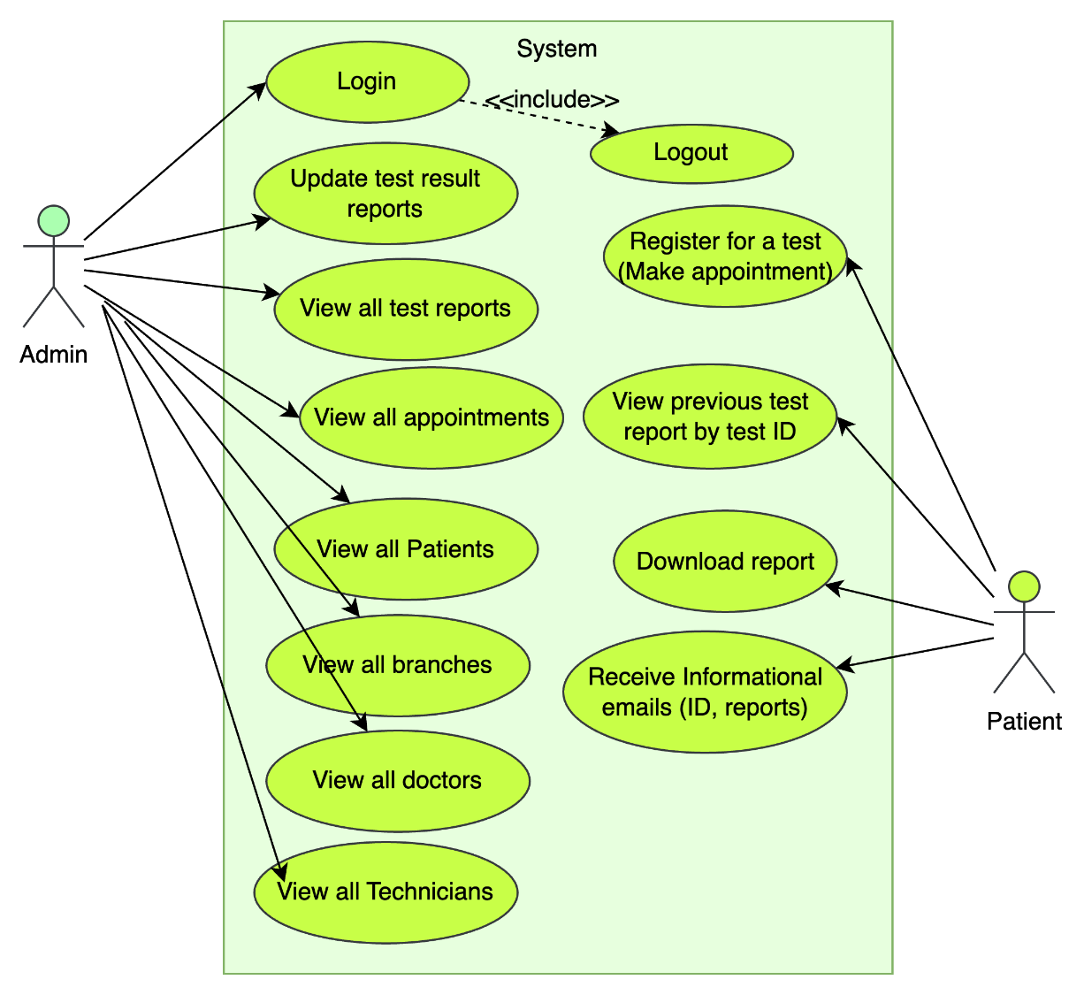

* Operating Environment

This application developed using latest version (3.2.3) of the Spring boot Framework with the maven build. To develop and test we used the Java JDK 17 LTS. Therefore, we recommend to use a server which has a Web container which supports Java 17 or later version. In testing scenarios, we recommend to use the JDK 17 or later to test to avoid unexpected behavior.

* Assumptions and Dependencies
* Every Branch has all Laboratory facilities.
* Every branch has a system admin
* Each admin has only access data (appointments, Technicians, Doctors etc.) to their respective branch.
* The report generation will do using a java desktop application which use Jasper Reports to generate reports.
* After the test complete the results will be added to report and send it to the admin and admin will upload the report to the system.

# **Technology Overview**

This application developed using Spring boot framework which based on Java Programming Language. As an object-oriented Language, Java allows to use Object Oriented design patterns to make codes more organized and make code maintenance more flexible. It also has packages called services which include all services classes which have businesses logics in them. The following diagram visualize how the components in web application interacts with each other.

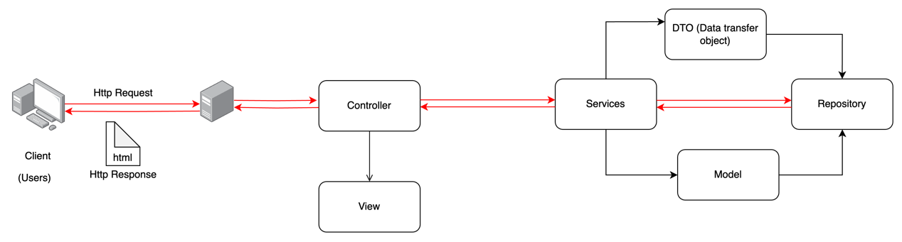

* Database Management

We have used Spring boot JPA which implemented the Hibernate framework. Hibernate Framework is a ORM (Object Relational Mapping). Which helps to develop applications and manage easily in the Java Language. In underlined structure it maps the data rows in the database to Java Objects. We used JDBC driver 8.0.28 which help to connect database to our web application. The following ER (Entity Relationship) diagram is a graphical representation of the Entities in the application.

* EER View



* Class Diagram View

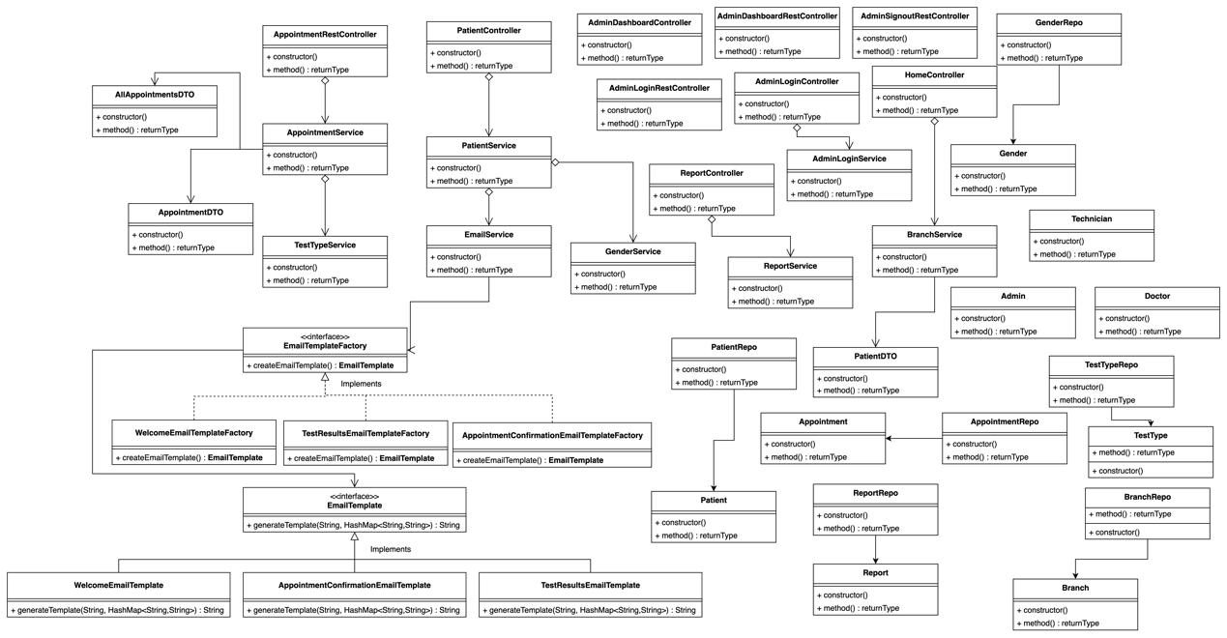

* Application Configurations

This application has few configurations in MySQL database connection, smtp mail sending etc. to make the application full functional. This application is developed using the Visual Studio (version 4.21.1. RELEASE). Therefore, we recommend to use SpringToolSuite4 IDE to do these configurations to avoid unexceptional results.

* Database Configurations

# Database Configuration

spring.datasource.url=jdbc:mysql://localhost:3306/abclabs_database

spring.datasource.username=root

spring.datasource.password=DY6yAmR3245

The database configurations are required to successfully connect to the MySQL database server. It has three properties to change there. First find the spring.datasource.url property and change the URL to the database. In local test scenarios it has only to change the database name and the port. Next Property is the spring. datasource.username and set the MySQL server username there. Next Property is spring. datasource.password and change the password which related to the user account which is with previously given username in MySQL server.

* Mail smtp configurations

spring.mail.host=smtp.gmail.com

spring.mail.port=587

spring.mail.username=example@gmail.com

spring.mail.password=pfky bmmw mfiq dyyf

These configurations required to make functional email services. If these configurations not configure correctly, the emails will not be sent to the customer.

To send emails we used the google smtp server. Therefore, to access this service we have to use a valid email address and password. This email will be shown to the customer as the sender of the email. Therefore, use a professional email format. Follow the following instructions.

1. Find the “spring.mail.username=” and give your valid Gmail address. Which must turn on 2FA (Two factor Authentication) in your google account using “manager your Google account”🡪2-step verification.

2. Find the “spring.mail.password=” and give you the app password you created for your app using your google account. Which is a 16-digits password which will give access to use your Gmail to send emails. Please refer this user [guide](https://support.google.com/accounts/answer/185833?hl=en) if you do not idea about app passwords. (<https://support.google.com/accounts/answer/185833?hl=en>)

# Specific Requirements

## External Interface Requirements

## User Interfaces

* Customer
  + 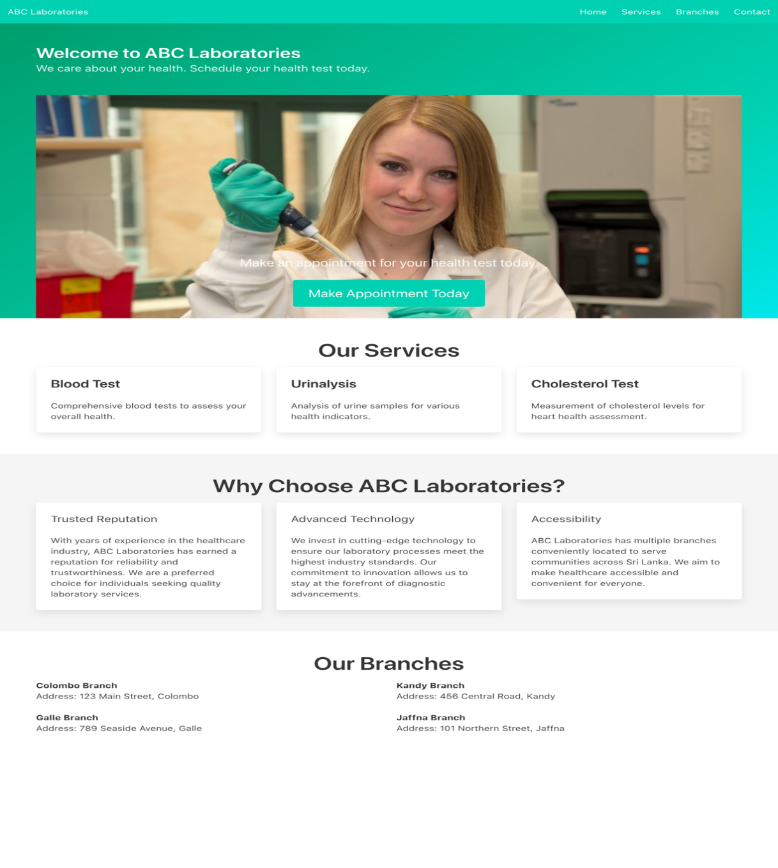Home page

Home page is the default page show when visit the web application. Home page has deferent sections. The top blue bar is the navigation bar. Which are focusing deferent sections in home page.

After the top bar it has a carousel with a image slider which has 3 images to decorate the page. The make Appointment button is use to direct user to make Appointment page.

* 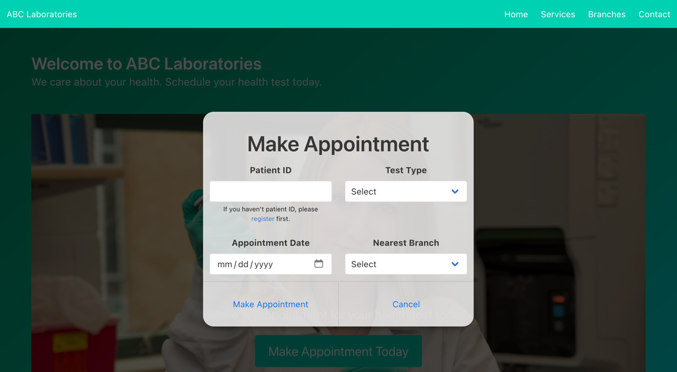Make Appointment

Make appointment page is use to reserve lab test appointments. All the fields are validated using front-end validations to avoid submitting unwanted data to the system.

If patient haven’t an ID, they can click on the blue color register link to redirect to patient registration page.

* Report

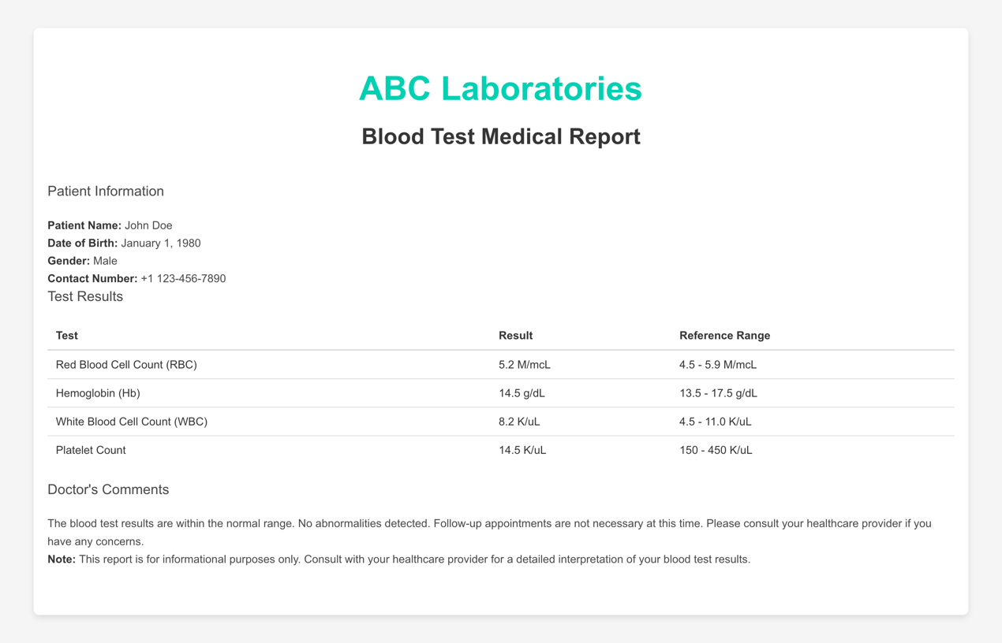

* + Patient Registration

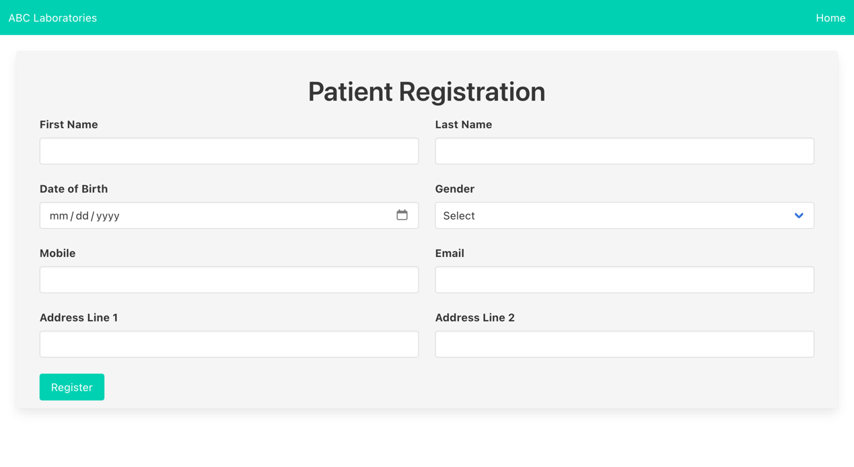

Patient registration page is use to vollect nessery data from the users and provide a unique ID to identify them. All fields are in this form are required fields. The fields validated in front-end and also in the backend server side.

* Admin
  + Dashboard

Admin dashboard has divided two main sections. The right-side bar is use to navigate between panels. The left side panel is viewing the relevant panel in that area.

* + - Appointments

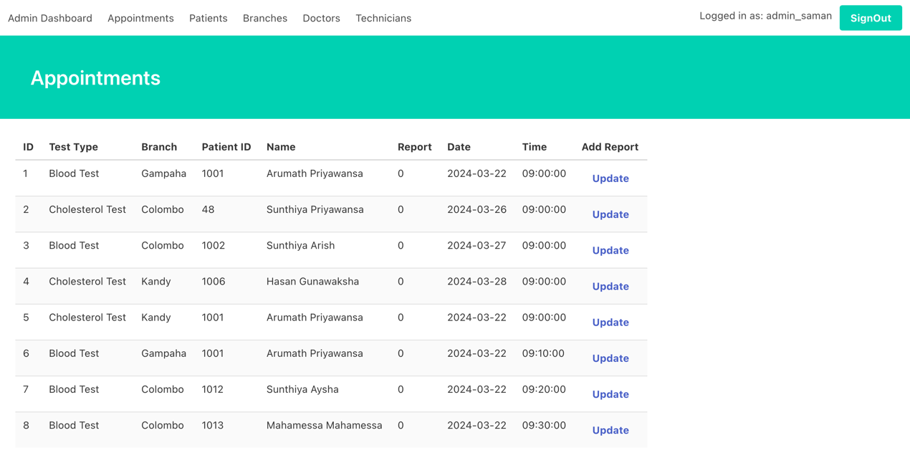

Appointments panel is the default panel in Admin Dashboard. In this view admin can view all available appointments. They can upload the report files when them issued form the lab. They choose the file using choose file. The opening window only focus on files with .pdf file. Because we have validated the file type in front end. In any case some browsers provide option to force select other file types also. Therefore, we have validate the file in the server side before save to the location. If the file is not a pdf file it will be send a response with error message.They can view uploaded file using the View button. If any issue with uploaded report they can re-upload the report. Once uploaded report the upload button change to Re-upload button.When file upload done user have to refresh the tab to view the updated columns.

* + - Patients

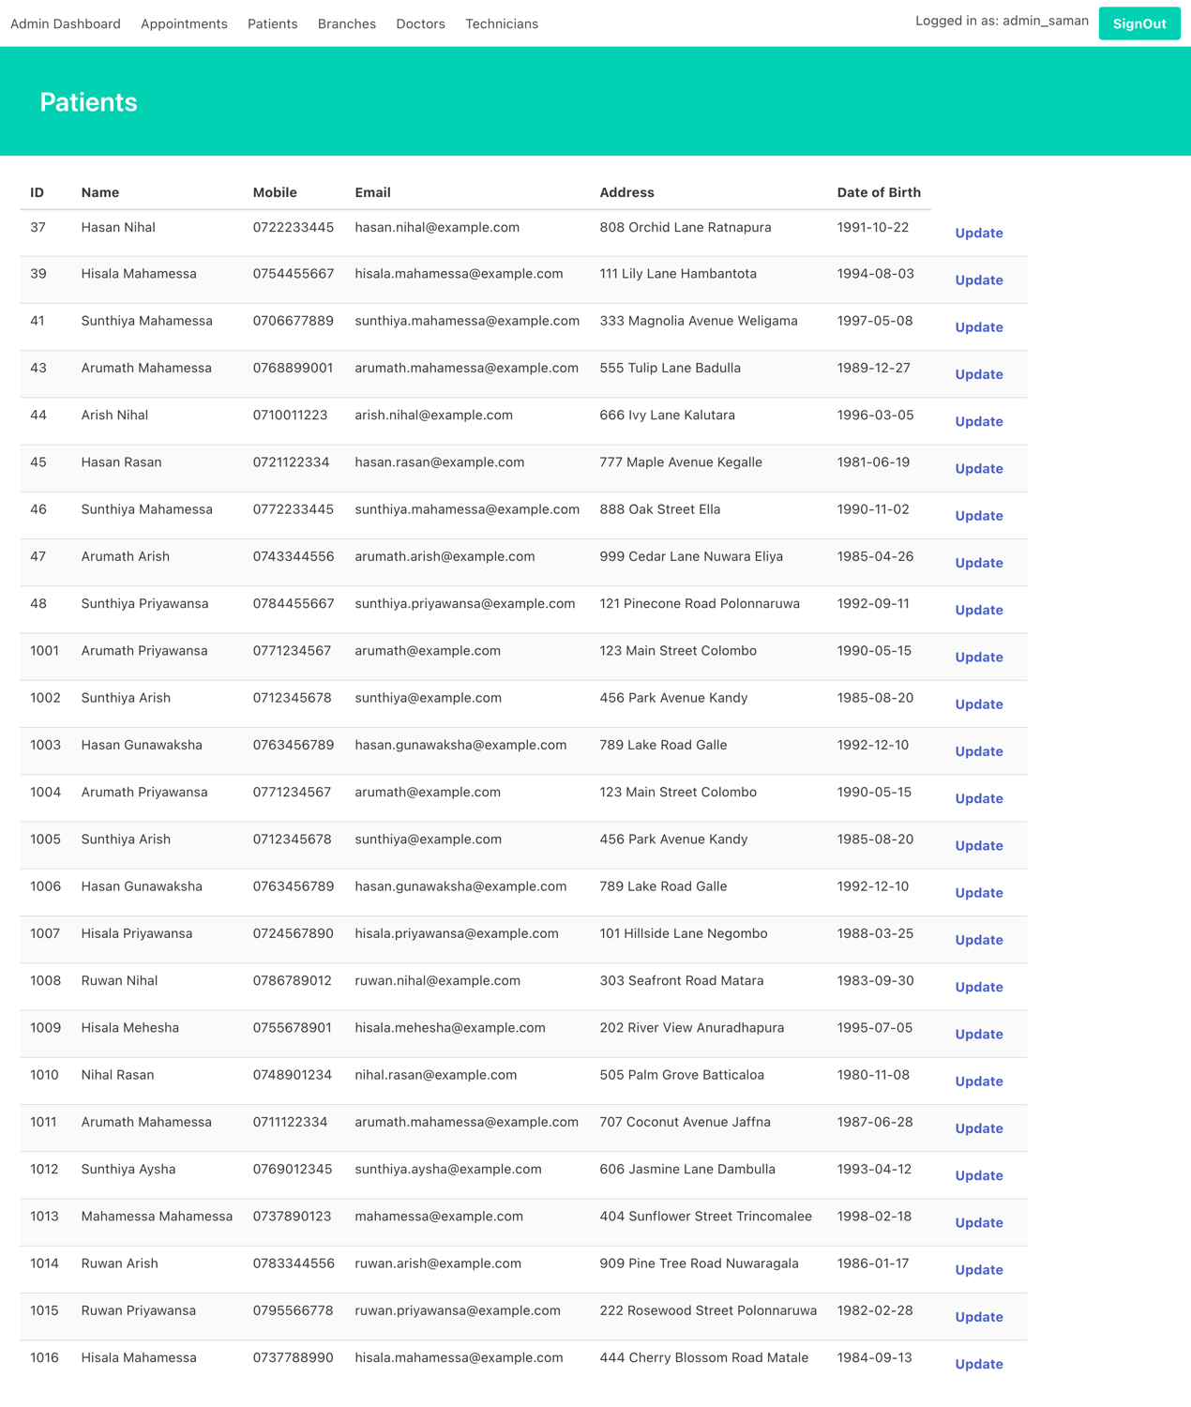

Patients panel will show all patients details who registered to the system.

* + - Doctors

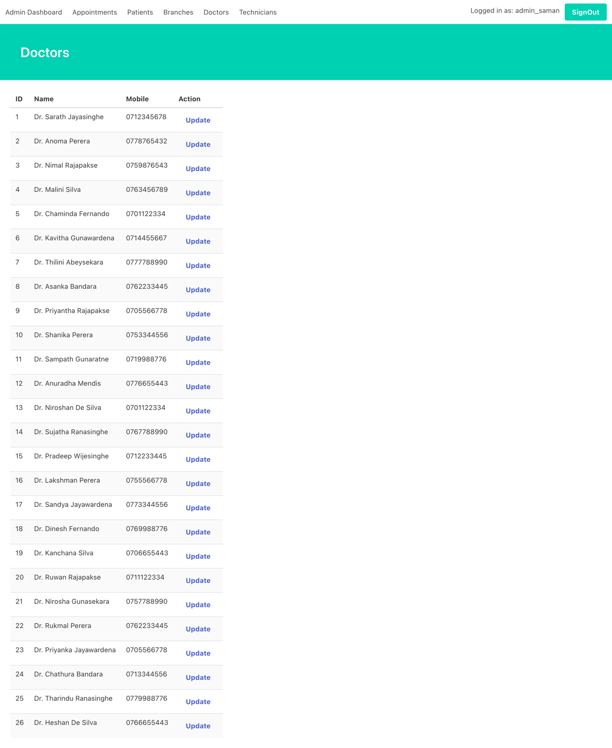

Doctors Panel will show all doctors who works in report checking, consulting and test supervision in ABC Laboratories.

* + - Technicians

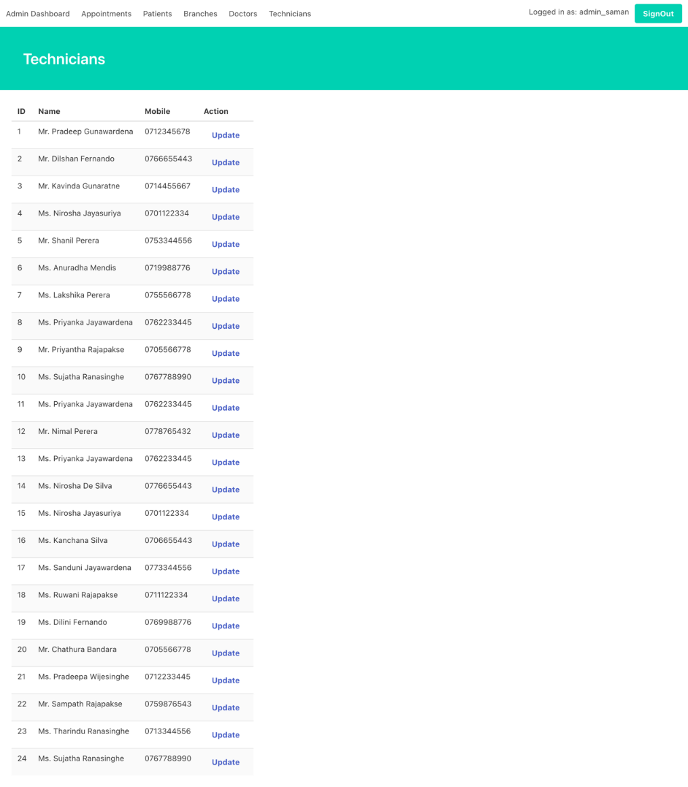

The technician panel is the view to see all Technicians works in the ABC labs. Technicians include lab assistants, supervisors, etc.

* + - Branches

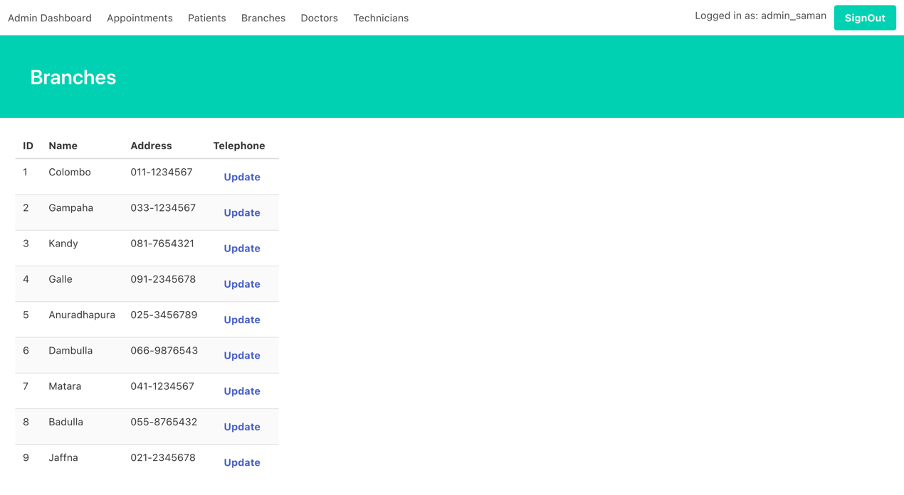

Branches panel will show all ABC Laboratories based in Sri Lanka.

* + Admin Login

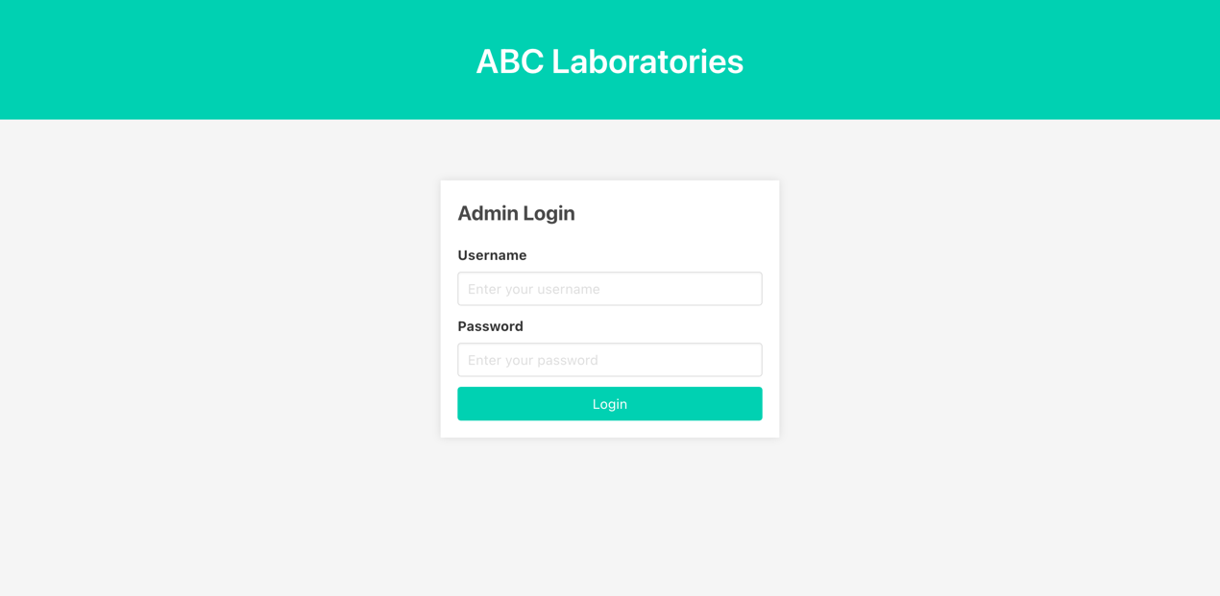Admin login is a simple and colourful login page. Admin login is the page use to admins log into the system.

**Tasks G**

Please refer my public remote repository https://github.com/bashitha17364/ABC-LAB for more updates

Link: <https://github.com/bashitha17364/ABC-LAB>

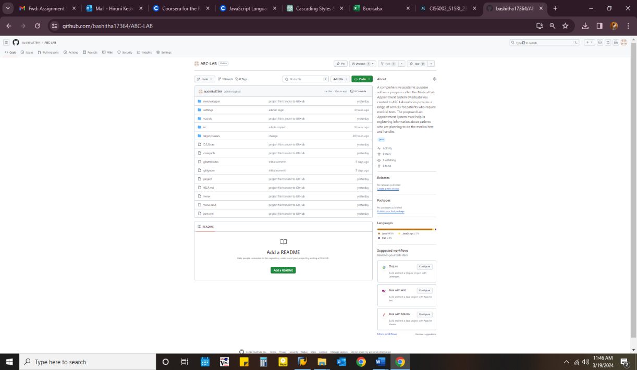

GitHub is web-based version control system designed to help developers effectively collaborate on projects, manage code repositories and track changes. It acts as a central place to host GIT repositories, which consist of written files and folders that make up a software project. GitHub; It has a variety of features, including issue tracking, code review tools, wikis and project management, all designed to facilitate collaboration between developers, groups and communities. With its easy-to-use interface and powerful tools, GitHub has become a major platform for software development, allowing individuals and organizations to collaborate seamlessly on projects of all sizes.

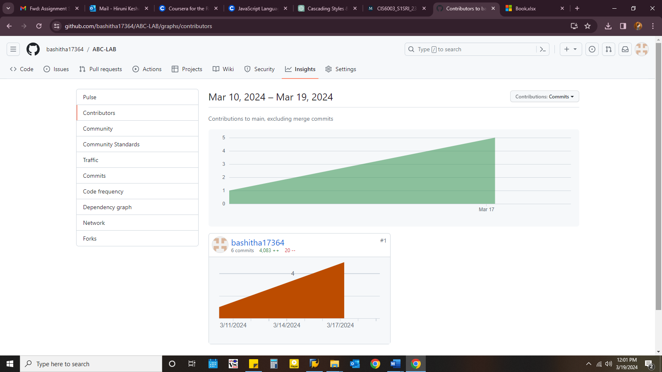

**GIT Flow**

Gitflow is a branching model for Git, proposed by Vincent Driessen in 2010. It defines a set of branching conventions that facilitate collaboration and streamline the release process in software development projects. The Gitflow model utilizes two main branches - master and develop - along with supporting branches for feature development, release preparation, hotfixes, and support. Here's a brief overview of the main branches and branch types in Gitflow:

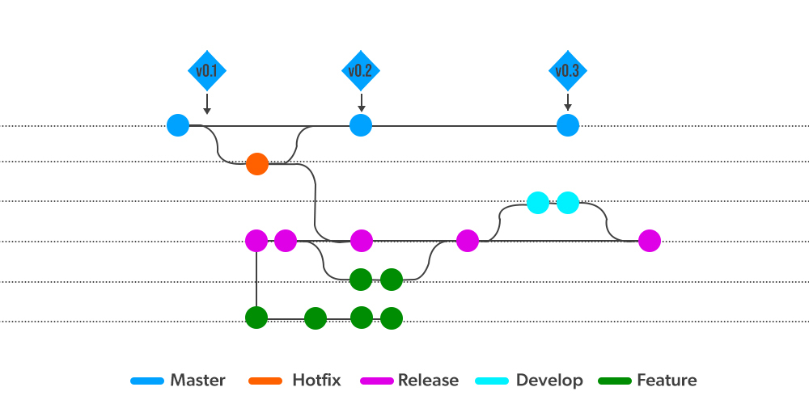

* Master Branch (master): This branch represents the production-ready codebase. It should ideally only contain code that is thoroughly tested and ready for deployment. Releases are made from this branch.
* Develop Branch (develop): The develop branch serves as the main integration branch for ongoing development. Feature branches are merged into this branch when they are completed and tested.
* Feature Branches (feature/): Feature branches are created for developing new features or enhancements. These branches are based on the develop branch and are merged back into develop once the feature is complete.
* Release Branches (release/): Release branches are used to prepare a new release. They are created from the develop branch when the development team decides to make a new release. Once the release is ready, the changes are merged into both master and develop, and the release branch is closed.

Hotfix Branches (hotfix/): Hotfix branches are created to address critical issues or bugs in the production codebase. They are based on the master branch, and changes made in hotfix branches are merged into both master and develop.

* Support Branches (support/): Support branches are used to maintain older versions of the software. They are based on tagged releases from the master branch and are used to apply patches or updates to those specific versions.
* The Gitflow model provides a structured approach to managing software development workflows, particularly for projects with frequent releases and multiple contributors. It helps teams keep track of different stages of development, isolate experimental features, and manage releases and hotfixes effectively.

**GitHub Flow**

GitHub Flow is a lightweight, branch-based workflow designed to facilitate collaboration and continuous delivery on GitHub. It is simpler than Gitflow and is often preferred for smaller teams or projects where a more straightforward approach to version control is desired. GitHub Flow revolves around a single branch, usually main or master, and emphasizes frequent deployments and fast iteration. Here's an overview of the GitHub Flow process:

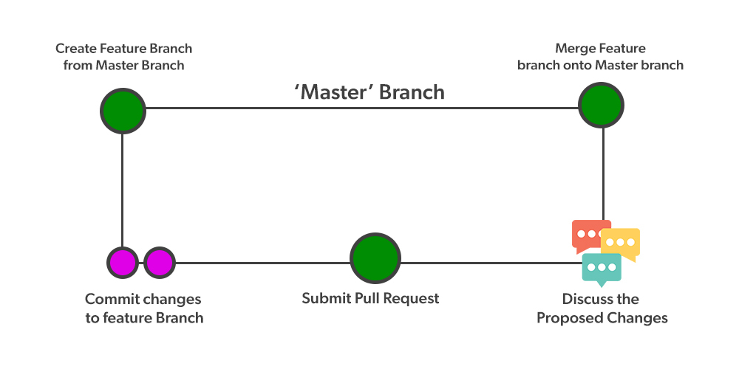

* Create a Branch: When working on a new feature, bug fix, or any other task, developers create a new branch from the main branch (main or master). Branch names should be descriptive and reflect the purpose of the changes.
* Add Commits: Developers make changes to the codebase within their feature branch, committing regularly to save progress and maintain a detailed history of changes.
* Open a Pull Request (PR): Once the feature is complete or the changes are ready for review, developers open a pull request to merge their branch into the main branch. Pull requests serve as a discussion forum where team members can review the code, leave comments, and request changes if necessary.
* Discuss and Review: Team members review the code changes in the pull request, provide feedback, and discuss any potential improvements or concerns. Code reviews are an essential part of the GitHub Flow process to ensure code quality and maintain consistency.
* Deploy and Test: After the pull request is approved and any necessary changes are made, the changes are merged into the main branch. Continuous integration and automated testing processes may be triggered to verify that the new code does not introduce any regressions or errors.
* Deploy to Production: Once the changes are merged into the main branch and pass all tests, they are deployed to the production environment. Continuous delivery practices are often employed to automate the deployment process and enable frequent releases.
* Monitor and Iterate: After deployment, developers monitor the production environment for any issues or performance concerns. If necessary, further iterations or bug fixes can be implemented by repeating the GitHub Flow process.
* GitHub Flow encourages a fast-paced, iterative approach to development, where small, incremental changes are continuously deployed and tested. It promotes collaboration, transparency, and code quality while enabling teams to deliver value to users quickly and efficiently.

Certainly! GitHub Flow is a lightweight and straightforward branching model that emphasizes simplicity, continuous delivery, and collaboration. That’s why I choose GitHub Flow.

# **Abbreviations**

| TERM/ACRONYM | DEFINITION |
| --- | --- |
| API | Application Program Interface |
| AUT | Application Under Test |
| SRS | System Requirement Specification |
| UML | Unified Modeling Language |
| JSP | Java Server Page |

# **References**

Shvets, A., 2019. *Factory Method.* [Online]   
Available at: https://refactoring.guru/design-patterns/factory-method  
[Accessed 28 02 2024].

Shvets, A., 2019. *Singleton.* [Online]   
Available at: https://refactoring.guru/design-patterns/singleton  
[Accessed 28 02 2024].

Shvets, A., 2019. *Abstract Factory.* [Online]   
Available at: https://refactoring.guru/design-patterns/abstract-factory  
[Accessed 28 02 2024].

Martin, R. C., 2002. *UML for Java Programmers.* s.l.:Alan Apt.

# **Turnitin Report**

